W-16

**YEAR 12 PHYSICS**

**ASSIGNMENT 3 - MOMENTS & EQUILIBRIUM**

**Name:** **Mark:** 

1. A car wheel is held in place by four nuts. Each nut was put on by a machine that tightened it with a torque of 3.00 × 102 Nm. The photograph below shows the 30.0 cm long horizontal lever that is used to remove the nuts from the wheel.

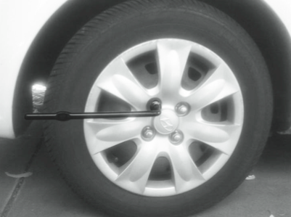

Assuming that it also takes 3.00 × 102 Nm to undo the nut, show (by calculation) that if a person of 90.0 kg stands on the end of the lever without bouncing, the weight is not enough to turn the wheel nut. (4 marks)

2. A thin metal rod is bent into a right angle and hung on a nail from a wall, as shown in the diagram. Assume that there is no contact between the rod and the wall. The longer side (L2) is 0.800 m and makes an angle of 14.0° to the vertical. The rod has uniform density and constant thickness. Calculate the length of the shorter side, L1. Show all workings. (4 marks)

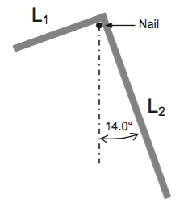

3. (a) The photographs above show the same chair in two different positions. A metre rule is included to provide scale. Photograph A shows the chair in the instant after the person holding it in place let go.

In Photograph A, the chair will begin to rotate and fall to the floor as soon as the hand is removed, while in Photograph B the chair will stay in the position as shown. Explain why the chair will rotate in Photograph A but not in Photograph B. (3 marks)

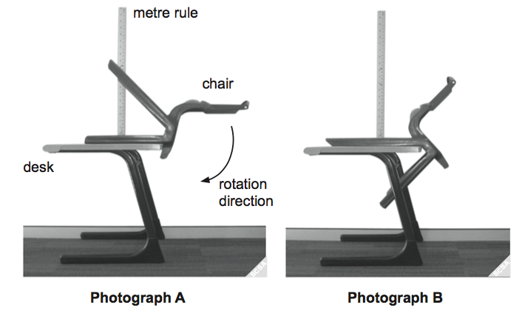

(b) On the photograph below, indicate the direction of the force that you could apply at Point X in order to prevent the chair from rotating. Estimate the magnitude of this force, stating clearly any assumptions that you make. (5 marks)

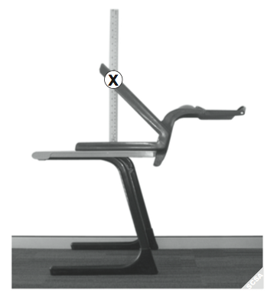

4. The diagram below shows a side view of a laptop computer resting on an outdoor table. The mass of the base of the laptop is 2.00 kg and the mass of the screen is 0.600 kg. They are both 22.0 cm long. There is an angle of 50.0° between the horizontal and the screen. The computer is blown over by wind.

Assume that the base and screen both have a uniform mass distribution.

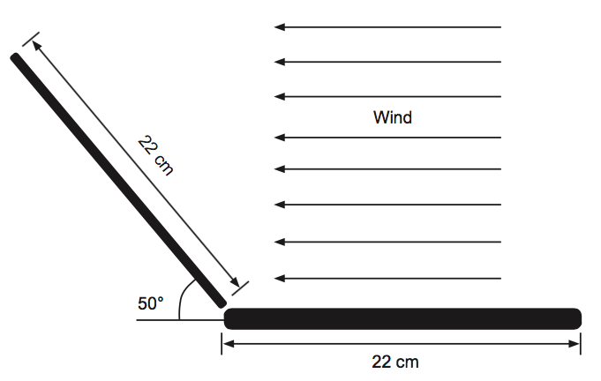

Calculate the minimum single equivalent wind force on the centre of the screen needed to tip the laptop over. (4 marks)

5. A uniform 1.00 x 102 g, metre-long ruler is placed on a table, with most of its length overhanging the edge. A 3.50 x 102 g slotted mass is placed at the ruler’s 50.0 cm mark, and a spring balance holds it up at one end, as shown in the diagram below.

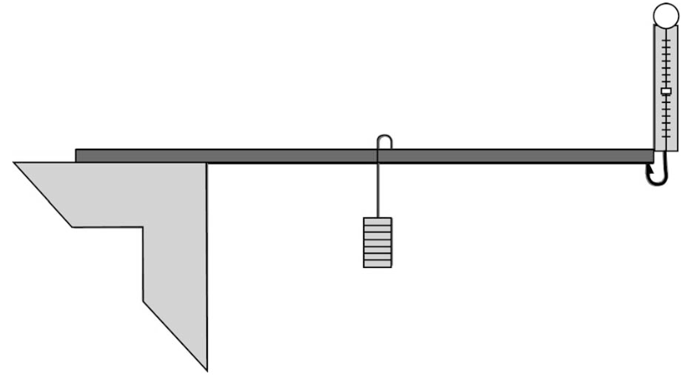

The ruler is just lifted using the spring balance so that it touches the table in only one place. At this point, the spring balance reads 2.20 N. Indicate on the diagram the fulcrum, or pivot point, for this action and label it ‘A’.

The ruler is then lowered slightly, changing the position of the fulcrum. Label this new fulcrum, or pivot point, ‘B’.

When the ruler is in this position, the spring balance reads 1.65 N. Determine the distance between the points ‘A’ and ‘B’. Note that the angle that the ruler makes with the horizontal has not changed significantly and should not be considered in your calculations. (4 marks)

6. A 3.00 m long plank with a mass of 10.0 kg is held by a cable at Point P, 0.200 m away from the upper end of the plank. The angle between plank and ground is 20.0° and the angle between plank and cable is 30.0°. A 2.00 kg cat moves up the plank up to Point Q, 2.40 m from the bottom, Point O.

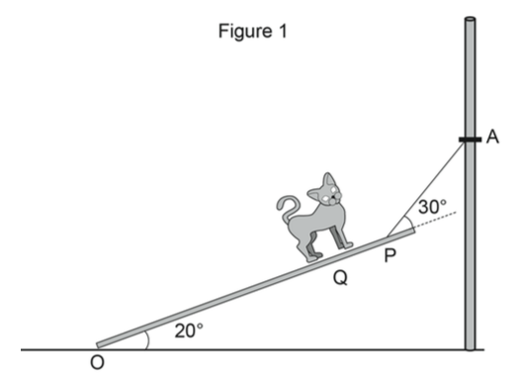

(a) Assuming that Point O is the pivot, calculate the tension in the cable. Show all workings. (6 marks)

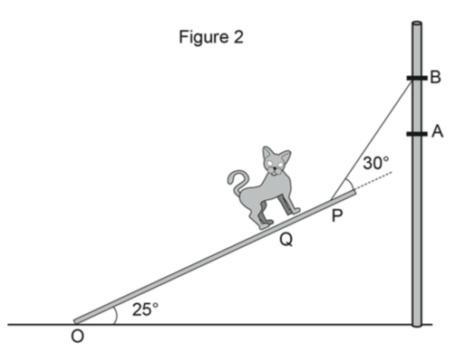

(b) The cable is then moved up from Point A to Point B while maintaining the angle between the plank and cable at 30.0°. The angle between the plank and ground increases to 25.0°, as in Figure 2. Assume Point O as the pivot.

(i) State whether the tension in the cable increases or decreases. (1 mark)

(ii) Justify your answer. (3 marks)

7. The diagram below shows a data projector with a mass of 7.00 kg. The projector is mounted on its uniform horizontal support arm at a distance of 0.500 m from the wall plate. The support arm itself is 0.900 m long and has a total mass of 1.00 kg.

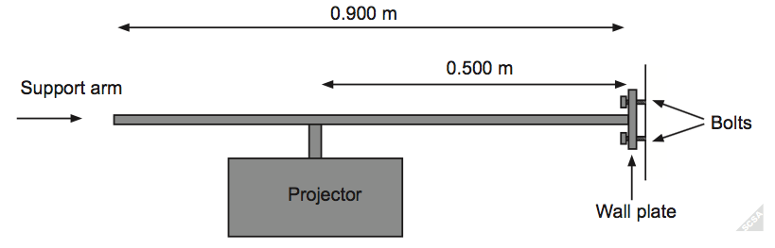

The assembly is held in place by bolts as shown in the diagram above. The upper bolt is 4.00 cm above the support arm and the lower bolt is 4.00 cm below the support arm. The wall plate does not touch the wall and is supported only by the bolts.

(a) Calculate the horizontal force in Newtons exerted by the upper bolt used to attach this projector to the wall. Show all workings.

Hint: Take the bottom bolt of the wall plate as a pivot point. (4 marks)

(b) Explain quantitatively the effect on the centre of mass of the projector/support arm system as the projector is moved further away from the wall. (3 marks)

(c) Explain quantitatively the effect on the horizontal force exerted by the upper bolt as the projector is moved further away from the wall, assuming the system maintains its stability. (3 marks)